
CONFIDENTIAL CS/NOV 2026/ICT450

UNIVERSITI TEKNOLOGI MARA FINAL EXAMINATION

COURSE
COURSE CODE
EXAMINATION TIME
DATABASE DESIGN AND DEVELOPMENT

ICT450
NOVEMBER 2026
3 HOURS

INSTRUCTIONS TO CANDIDATES

- This question paper consists of five (5) questions.

- Answer ALL questions in the Answer Booklet. Start each answer on a new page.

- Do not bring any material into the examination room unless permission is given by the invigilator .
- Please check to make sure that this examination pack consists of: i) the Question Paper
  - an Answer Booklet - provided by the Faculty

- Answer ALL questions in English.

DO NOT TURN THIS PAGE UNTIL YOU ARE TOLD TO DO SO

This examination paper consists of 6 printed pages.

QUESTION 1 (20 marks)
a) Database is the best way to store and manage data. Identify FOUR (4) data that will be involved in online purchasing.
(4 marks)
Table 2: COURSE table
COURSE_ID | COURSE_NAME
10 | Networking
20 | Software Developer
30 | Web Designer
40 | Database Developer
50 | Data Analyst
60 | IT Professional
b) Describe the basic features of the relational data model and discuss their importance to the end user and the designer.
(4 marks)
c) Table 1, 2 and 3 show the data in a local IT learning academy that is famous for various computer learning courses. Because of its popularity, there are increasing number of students enrol in the academy. Since then, the academy needs an efficient automated data storage, hence you are required to determine relational keys to ensure each row in the table is uniquely identifiable.
i) Identify THREE (3) possible superkeys, TWO (2) candidate keys and primary key(s) for the STUDENT table. Justify your answer.
(6 marks)
ii) Do the tables display both entity integrity and referential integrity? Answer YES or NO, and then explain your answer for each table.
(6 marks)
Table 1: STUDENT table
STUDENT_IC | STUDENT_ID | FIRST_NAME | LAST_NAME | EMAIL | COURSE_ID
80193939979 | 202587788 | Ahmad | Ali | AA@gmail.com | 40
40122566748 | 202575526 | Haqiem | Rosly | haqiem@gmail.com | 40
20164723670 | 202552244 | Wany | Hazwan | wany@gmail.com | 50
10108990074 | 202536987 | Haliza | Husni | Ha@gmail.com | 50
80116756736 | 202512369 | Heechul | Kim | heechul@gmail.com | 40
90137476323 | 202533969 | James | Reece | james@gmail.com | 20
50143670971 | 202574563 | Canos | Sergi | Ola21@gmail.com | 20
QUESTION 2 (20 marks)
a) Database Life Cycle (DBLC) is a properly designed framework for implementing a database system. The proper database design leads to an efficient data retrieval. Briefly explain FOUR (4) activities in the database design phase.
(8 marks)
b) XYZ Technologies Sdn. Bhd. is planning to implement a mobile database for their company due to increasing branches in Malaysia and Indonesia. Do you think that mobile database is suitable for this company? Briefly describe THERE (3) factors that contribute to the wide usage of mobile database.
(8 marks)
c) Data is a raw and unorganized fact that required to be processed to make it meaningful. State the differences between structured and unstructured data.
(4 marks)
QUESTION 3 (20 marks)
Figure 1 shows the boarding pass for domestic flight in Malaysia. One customer can visit to many destinations and each destination can be visited by many customers.
The structure of boarding is given as the following relational schema.
BOARDING (CustIC, CustFirstName, CustLastName, {FlightID, PlaneType, Capacity, DestinationID, DestinationName}, DateDepart, DateArrive, TimeDepart, TimeArrive, Seat)
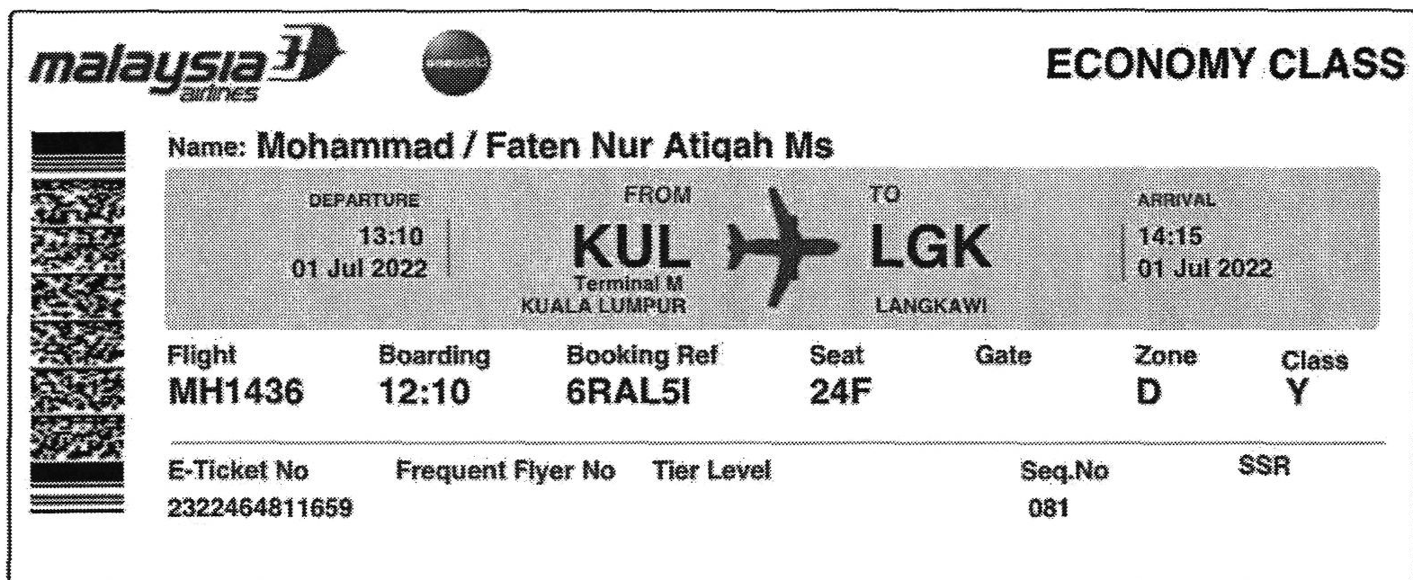
Figure 1 : Boarding Pass
a) Define normalization and describe the importance of having normalization in database design.
(3 marks)
b) Describe THREE (3) requirements for good normalized set of tables. Give an example for each requirements.
(6 marks)
c) Show all the steps to normalize the structure until third normal form (3NF). The primary key(s), partial dependencies and/or transitive dependencies need to be clearly identified.
(11 marks)
QUESTION 4 (20 marks)
The relational schema below shows the movie database system.
MOVIE (MovieID, MovieName, Genre, DateRelease, NetProfit, DirectorID*)
DIRECTOR (DirectorID, DirectorName, Nationality)
REVIEW (ReviewID, Description, MovieID*, ReviewerID*)
REVIEWER (ReviewerID, ReviewerName)
Write the SQL statements based on the following requirements:
a) Display the movies that have been released from 2021 until 2023.
(4 marks)
b) Identify the total movies that have been directed by Malaysian directors.
(4 marks)
c) Calculate the average net profit for each genre and name the output as "Average Net Profit".
(4 marks)
d) Identify the reviewer's name(s) that has made more than 2 reviews.
(4 marks)
e) Display the movie that received the most reviews.
(4 marks)
QUESTION 5 (20 marks)
Excellent Art is a company that provide art training for children who are interested in it. The company mission is to promote creative and innovative thinking in children's life.
- There are about 15 Excellent Art studios around Malaysia. To uniquely identify each art studio, they had been assigned with a unique studio id. Other important information that needs to be kept in the database are studio name, address, phone number, email, and GPS coordinate.
- Each studio deals with many suppliers, which supply a variety of art materials. Art material information need to be recorded are art material id, name, description, and price. The information about the supplier that must be recorded is its unique id, name, address, and email.
- One art studio provides many programs. Each program will uniquely have identified by program id, name, description, and price. The programs are classified to Visual Art, Glass Painting and Handicraft. Each of the program will have their own additional information, such as, Visual Art program will have class type, Glass Painting program will have program level, with value 1 to 5 as it will indicate the technique in glass painting and Handicraft program will need craft data.
- There are about 100 employees all together in the Excellent Art company. Each employee has a unique employee number, first name, last name, job titles and date of birth and is allocated to only one art studio. Each studio has several employees. However, each employee only can work in one studio.
- If an employee currently married to another employee of the same studio, the spouse's employee number and date of marriage is also recorded.
- To be creative, many employees in the studio acquire many skills. Skills data to be recorded are skill type and skill description.
a) Construct an Entity Relationship Diagram (ERD) complete with all the required tables, attributes, relationships as well as the cardinalities using the Crow's Foot notation that reflects all the given business rules.
(16 marks)
b) List TWO (2) example of reports that can be produced from this database system.
(4 marks)

